RESEARCH STUDY FOR THE NECESSITY OF IMPLEMENTATION OF AN AUTOMATED POINT MANAGEMENT SYSTEM IN FAST NUCES KARACHI

Prepared for

*Faiza Mumtaz*

Lecturer, Department of Science and Humanities

FAST NUCES Karachi

By

*Sufyan Siddiqui*

18K-1161 - FAST NUCES Karachi

*Muhammad Mudassir*

18K-1042 - FAST NUCES Karachi

*Ammarah Abid*

18K-0214 - FAST NUCES Karachi

*Mariam Munaf*

18K-0143 - FAST NUCES Karachi

*Sharyar Shafi*

18K-0266 - FAST NUCES Karachi

May 24th, 2021

Table of Contents

1. Abstract 3

2. Review of Literature 3

3. Introduction 4

4. Methodology 5

5. Results 5

6. Conclusion 9

# Abstract

In today’s era of technology, every system is getting automated. Therefore, for the need of the implementation on an Automated Point management System in FAST Karachi, we conducted a survey in which different questions were asked from the individuals to have first-hand knowledge of the issue that whether the individuals who use point facility need automation in the system, are they satisfied with the current system and, what are the functionalities and services they want to have in the automation of Point Management System. The responses were then analyzed by exploratory data analysis using python pandas modules and the results showed that the majority of the individuals were in the support of the need for an Online Point Management System. The System should be intelligently utilizing the safety and security sensors along with the features of real-time tracking by the employment of GPS Sensors in the Points. The System should also provide the facility of E-Billing and the real-time information of Vehicle, Drivers and the Routes of their respective Point. The Implementation of an Intelligent Point Management System will eventually provide ease to the Students and Veterans who avail Point Facility and to the Management Team of Point Services in FAST Karachi.

# Review of Literature

As we move in a metropolitan city which certainly has its own merits and demerits, on the other hand, there seems to be an urge as per the results of the research survey conducted [1,6], to avoid irritating situations in using transportation for university students, faculty and, non-faculty members. To tackle the issues such as traffic congestion, no-real time information [6], unexpected delays and, unorganized dispatching of buses/point from the terminal as well as issues such as addressing the security concerns of both students and their guardians since the rate of street crimes has an increase in the last few years, the need to use an automated transport system has increased as well. That transport system should be able to track the points in real-time to fulfil the requirements and, for this particular reason, Radio-Frequency Identification (RFID) alongside with Global Positioning System (GPS) technology should be planted in the points [1,5,6], so that people who avail this service do not have to wait for points alongside with the benefit for their guardians such that they will be able to track their children [1,6]. The university management will also be able to obtain real-time information of points, drivers and passengers. This will enhance the security of the point facility [1,5].

Another big concern is the management of large amounts of data which includes the data for Fee, Registration, Drivers and Vehicles. University and the Point Administrators along with their staff face a tough time managing the data as per the analysis of results of the questionnaire distributed among the relevant individuals and of several case studies [2,4]. The management of the data from the paper-based records for the Transportation System is time-consuming and will eventually require more resources and space for the maintenance of the records. Along with the stated issue, there is also a need for the accurate and proper information of the passengers present in the vehicle, to ensure the safety of other passengers and the vehicle and the integrity of the system. The automated system will provide paperless transport management [2,4], increase productivity [2] proper e-billing [2,4], a facility that will enable the passengers to reserve and cancel their seats [4], and, the structured data of Passengers and the other entities [2,4]. The system should use technologies such as PHP, JavaScript for building purposes and AJAX for faster access to databases for a more user-responsive experience [2].

Even though the Automated Transportation System is already built and used by the management staff, there is still a need found by the proper Software Analysis and Designing for its mutation to make the system more simple and easy-to-manage [7]. The database structure of the traditional system is complicated yet complex to manage which eventually decreases the efficiency of the system as well as requires more energy and hard work to run complex queries to extract the required data out of it. The Analysis showed that the huge system should be divided into modules for administrative and user purposes. The administrative part will include separate modules for Vehicles, Drivers, Students, Veterans and Routes. On the other hand, the User part will include Login forms, Routes and Registration modules [7].

There is a wide area of concern that still exists for the passengers and other entities present in a point/bus which is accidents. The research survey concluded that people using university transportation are concerned about the air and noise pollution they experience as well as they have a fear of accidents caused due to the uncertain traffic of the city [8]. Another similar survey found several more issues such as traffic jams and drivers' autonomy and their behavioural issues for passengers living in distant areas [9]. To tackle such issues, there is a need for an Intelligent Transportation System [10], that will have GPS installed along with the safety sensors such as Radars, LiDAR, ultrasonic and, vision-based sensors [8,10]. These sensors and technology will eventually help in gathering the real-time data and based upon that data the drivers will take better decisions to avoid the polluted routes, take routes that are safe and on which the traffic is in order such that the possibilities of accidents are minimized [8].

Conclusively, the point management system is required to be developed in a modular fashion [7], with the intelligent functionalities by using RFID [1], GPS [5,6,8,10], and other safety sensors [8,10], with faster access to the database using AJAX [2] and, proper e-billing (fee) and paperless management [2,4].

# Introduction

Automation of processes is becoming essential nowadays. The emergence of technologies made it quite easier yet economical to perform manual tasks automatically by using suitable technologies. Transportation services are also getting automated in the world. The process of booking, cancellation and payment is somehow automated. Long queues of people outside the ticket counter are converted into long priority queues of objects inside the software. The rise of the need for automated systems is due to the drawbacks of manual systems requiring more effort and cost [2,4]. In some cases of transportation system automation, the reason is to reduce the waiting time of the passengers who wait for the point at their stops. The implementation of smart geo sensors such as the Global Positioning System (GPS) will eventually help the waiting ones to arrive at their stops on time. Another reason is the real-time identification of the passengers to ensure the element of safety by using sensors such as Radio-Frequency Identification (RFID) [1,5,6]. Moreover, paper-based systems are quite difficult to manage and keep the continuously increasing data. They eventually require more resources to handle the work [2,4]. While with automated systems, data processing and management will become quite easy. The system should be web-based to enable the facility of remote access and data security [2,4]. A system divided into modules works much faster than a centralized system having a single database structure to process queries [7]. [8,10] already researched that the installation of safety sensors such as vision-based, LiDAR and, ultrasonic sensors will help the driver finding the best routes with minimum probabilities of accidents and unavoidable situations.

In this report, we are focusing on the current situation of the Point Management System in FAST NUCES Karachi. The current situation of the system is quite old and somehow has problems with it. Currently, the university uses a paper-based Point Management System that registers the students by paper-based forms and the fee management is also manual. The disadvantages of the current system are mainly, long waiting queues for registration, no real-time information of points, drivers, students and other passengers in a point. This research aims to find out the relevance of the implementation of an automated point management system in FAST Karachi. We want to know how effective this implementation will be for the University Management, Students and Staff for the everyday use of points and the registration process at the start of each semester. Online Survey will be done to get the firsthand opinions of the population of FAST NUCES Karachi including the Students, Faculty and other staff regarding the implementation of an Automated Point Management System on campus. Finally, through this research study, we are going to conclude that the Implementation of the Automated Point Management System in FAST NUCES Karachi will not only enhance the security of the passengers and the vehicle but also will provide sustainable yet reliable management of the point service from registrations till fee processing and the importance of the use of safety and geo sensors in points to get real-time information remotely.

# Methodology

The data collection for the research is based upon the online questionnaire that was shared with the students of FAST NUCES Karachi who use the point facility. Questions present in the questionnaire were covering different aspects of the importance of an automated system. The answers to the questions in the questionnaire were categorical and consisted of multiple choices each having its own significance by means of the ranks of answers. Questions in the survey form start from the question of a satisfactory level of the current system and end at the need of this system covering all the aspects in between and, at last giving us the relevance of the implementation of this automated point management system.

# Results

From the questionnaire designed to find out the need and impact of the Implementation of an Automated Point Management System in FAST Karachi, we received sixty-four responses. Those responses were provided us with insights that how the individuals are dealing with the current paper-based system of Points and whether they want a change in the system.

The findings of the research are defined below:

1. **The convenience of Point Services as compared to Public Transport**

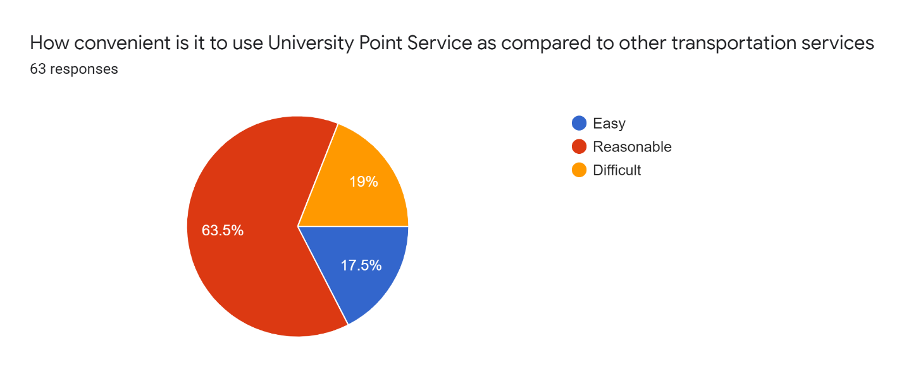

As defined in the chart that 63.5% of the individuals found it reasonable to use University Point Service than to avail Public Transport due to the punctuality and safety of University Point Services. While 19% of the individuals find it difficult and with a sample of 17.5% of the total individuals who took part in the survey it is declared easy.

1. **Need of an Online Point Management System**

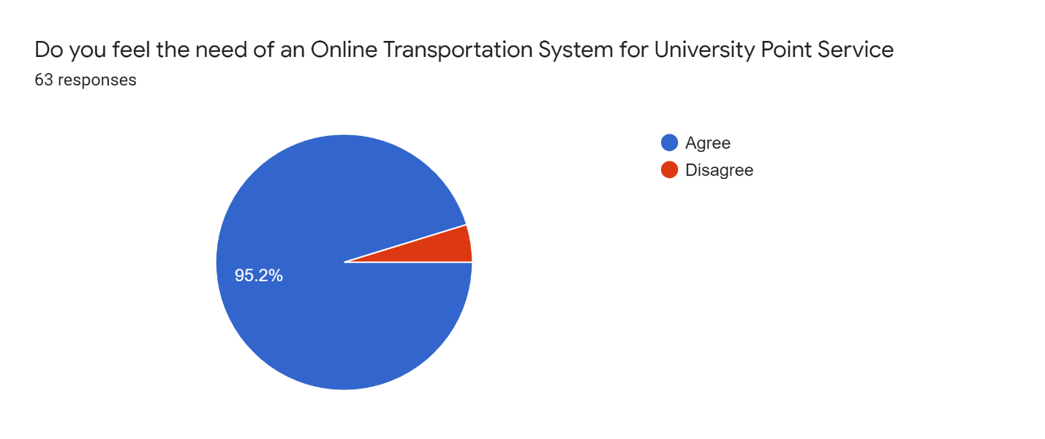

When asked regarding the need for an Automated Point Management System, 95.2% of the total individuals agreed to it making it quite accurate that Automation is necessary for Point Management Services. Meanwhile, a small number of people found themselves satisfied with the current paper-based system.

1. **Need of real-time information of Routes of Points**

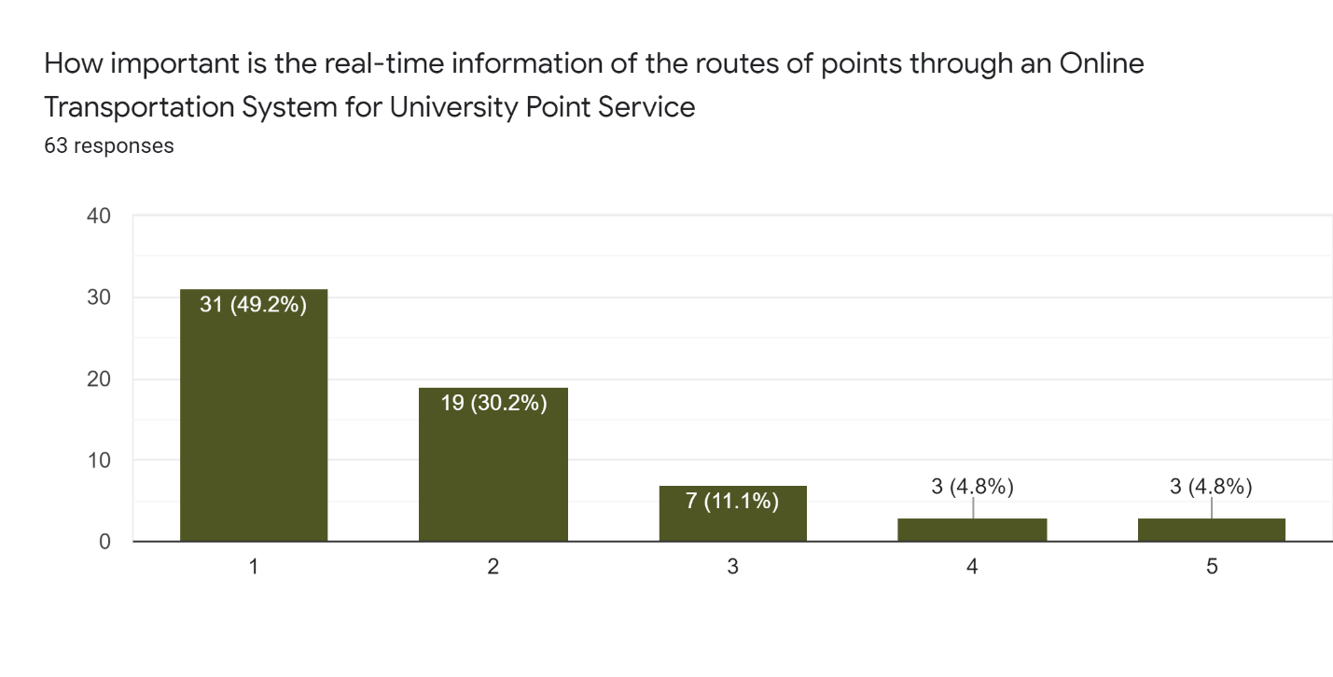

It is evident from the results of the research that the majority of the individuals found it necessary to have real-time information of the daily routes of the specific point they are travelling in at the moment. Whereas, only 3 individuals found it unnecessary to have this information.

1. **Need of real-time information of Vehicles used as Points**

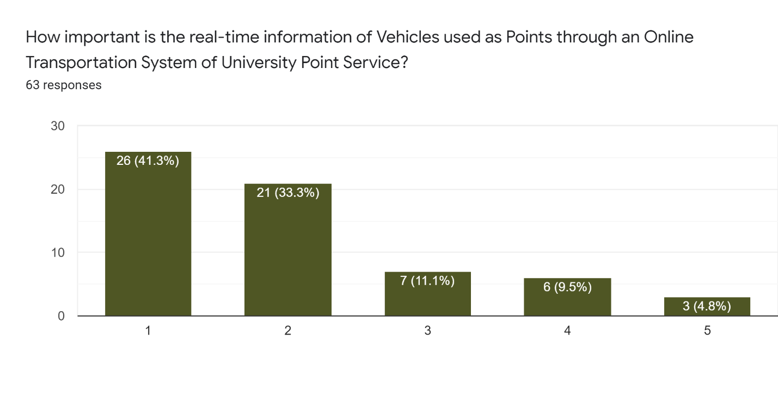

For the real-time information of Vehicles used as Points, the majority of individuals marked it extremely important to have that facility in the Point Management System to be aware of the details of the vehicle they are travelling in.

1. **Need of real-time information of Drivers of Points**

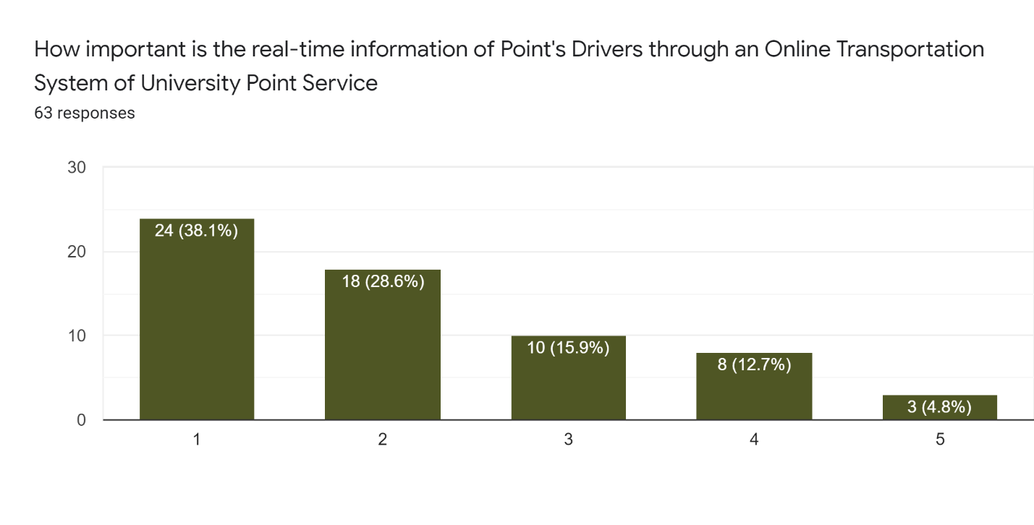

The majority of the individuals who participated in the survey marked it extremely important to have the information of driver(s) they are travelling with to be more secure and safe.

1. **Need of real-time tracking of Points through GPS**

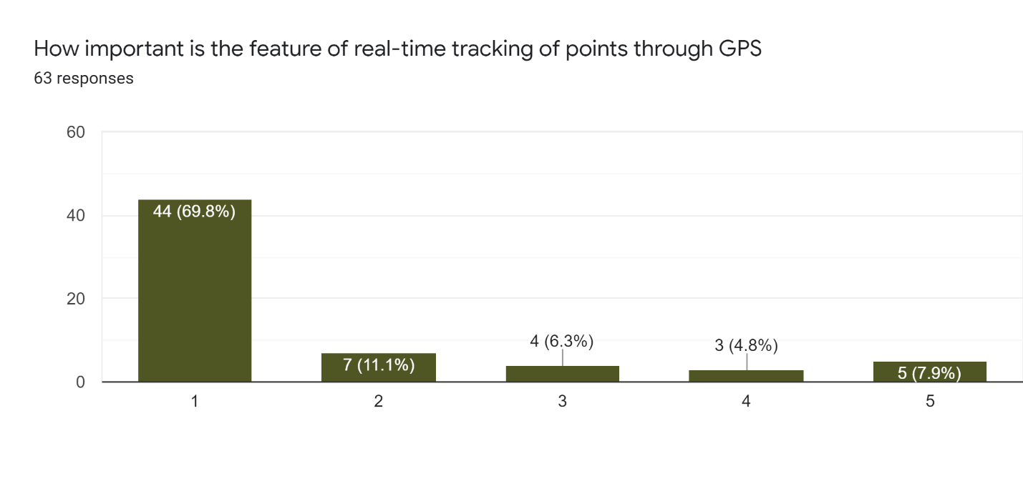

According to the research, 44 out of the 64 individuals found it important to have the real-time location information of Points through GPS Sensor that makes it a majority with 69.8% of the total participants who took part in the research.

1. **Satisfaction with the current paper-based registration system of Point Service**

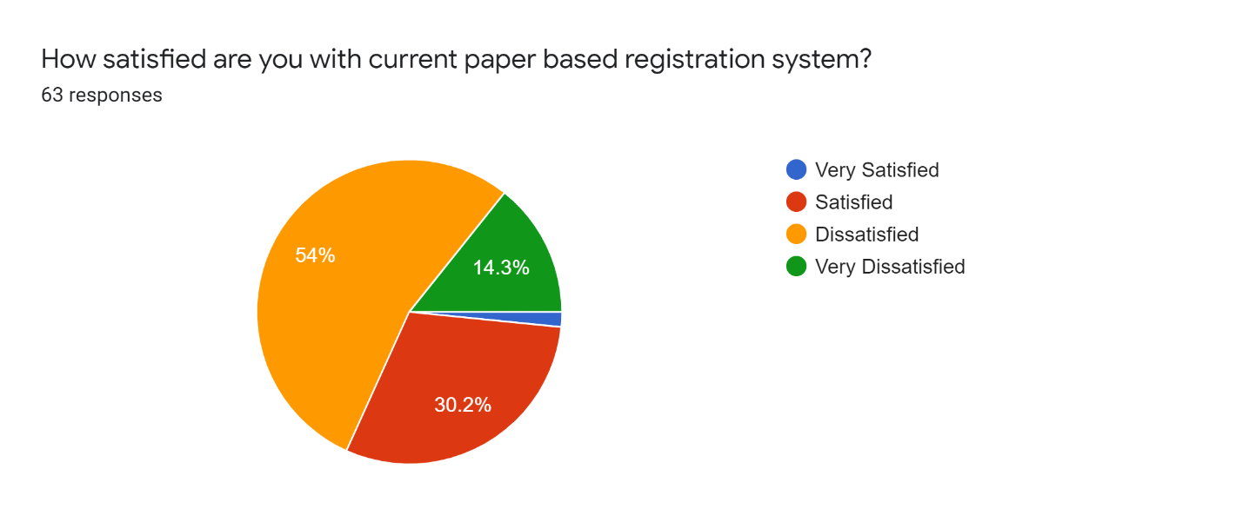

It is visible in the chart that the majority of the individuals are dissatisfied with the current paper-based registration system of points with a percentage of 54% dissatisfied and 14.3% very dissatisfied individuals collectively providing shreds of evidence that the current system is not even satisfactory in terms of its operations.

1. **Need of Online Registration of Point Service**

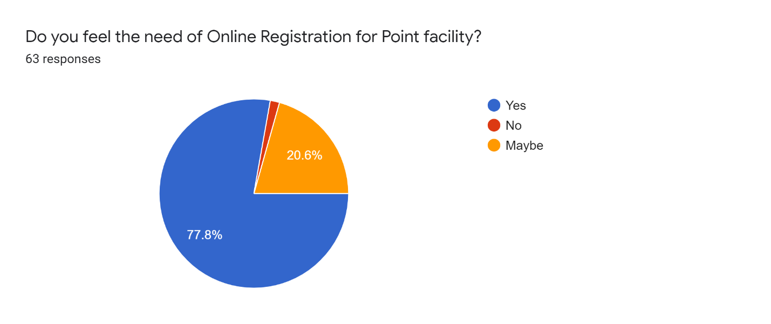

A large number of participants with a percentage of 77.8% of the total participants for this research survey indicated that they are in utmost need of an Online Registration System as compared to the current Paper-Based Registration System for Point Service in the university.

1. **Need of E-Billing System to Pay Point Service Charge**

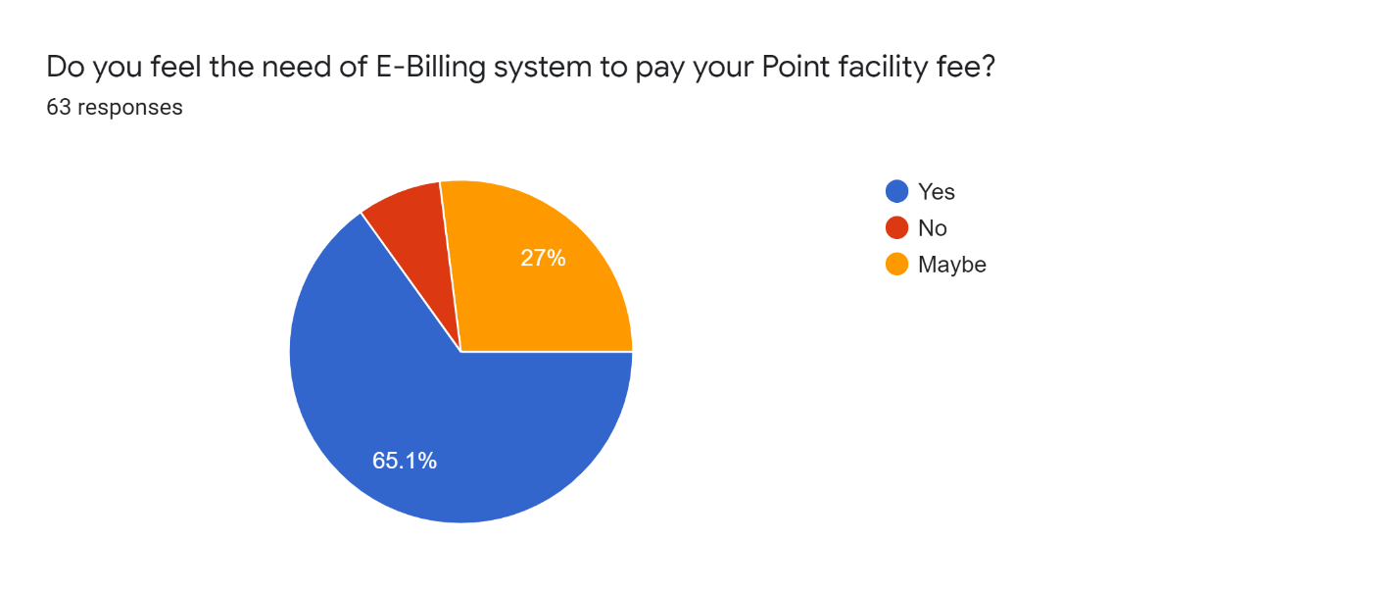

The need for the e-billing facility in the implementation of an automated point management system was supported by the majority of the individuals that took part in the research survey. The votes in favour of this feature were 65.1% and on the second spot, 27% of individuals voted for maybe and, rest for no proving that there is an utmost need for the installation of the e-billing facility.

1. **Need of Intelligent Point Management System by using Safety and Security Sensors**

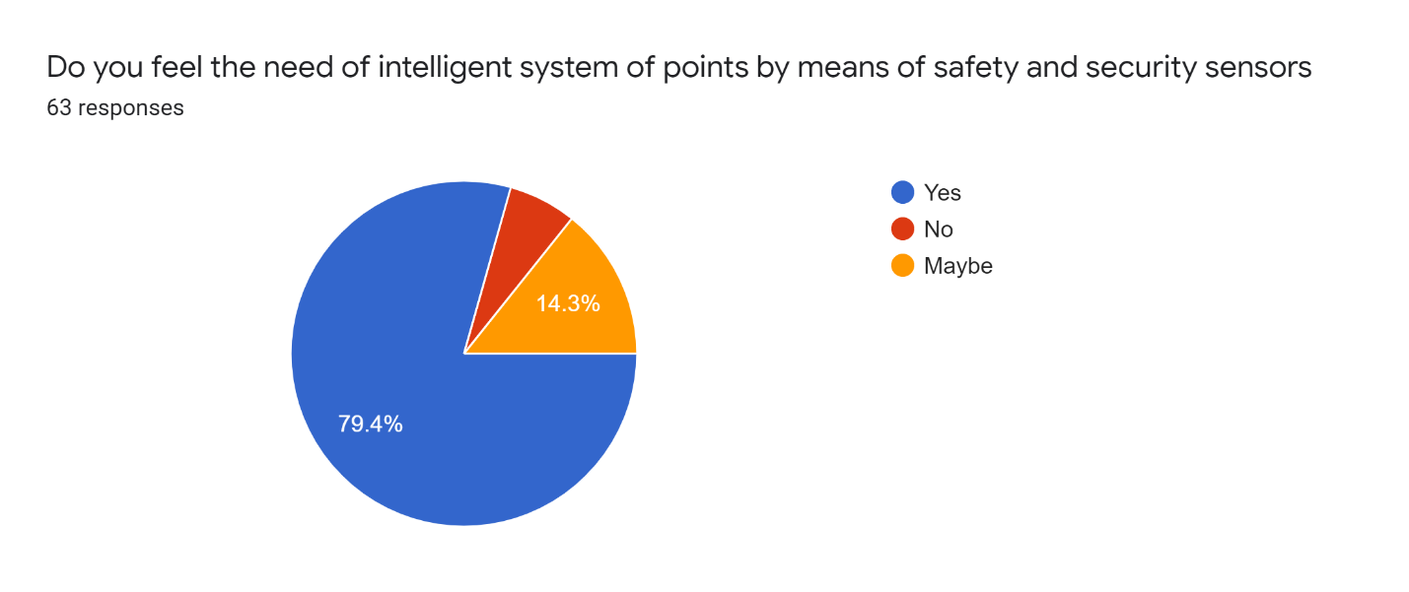

The need for Intelligent System of Point Services utilizing using safety and security sensors was supported by 79.4% of the individuals who answered yes. On the other hand, 14.3% of the individuals were unsure by answering maybe and, rest of the individuals marked no for this question making it a majority supported need by 50 out of 64 individuals.

# Conclusion

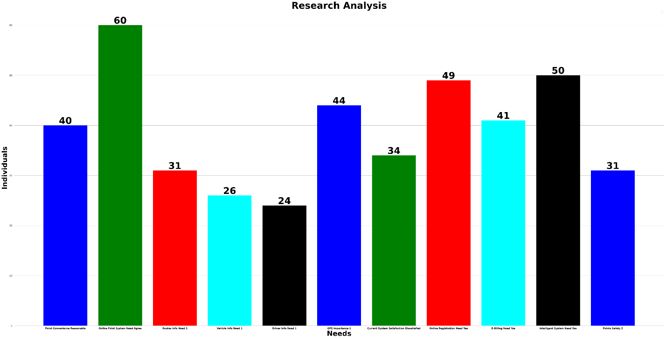

After performing a Data Analysis of the compiled data from the conducted survey by using Python Data Analysis techniques, it is therefore concluded that more than 90% supported the fact that there is an urge of Online Point System in FAST Karachi. Second, the majorly voted concern was to implement an Intelligent System of Point Service by 83% of the population. While the third most supported point was to have a facility of Online Registration for Point Services by 49 out of 64 individuals with a percentage of 81.6%. On the fourth priority, Online GPS Tracking of Points was supported by 73% of the individuals who found it extremely important that the tracking of points should be done employing GPS Sensors. Meanwhile, individuals who found it necessary to have an E-Billing Facility and who found Point Facility reasonable as compared to Public Transport are 68% and 66% respectively of the total making it the Fifth priority wise issue. The sixth most priority wise point was the dissatisfaction of the people with the current paper-based system by 56% of the individuals. Furthermore, 51.6% of the individuals found it extremely important to have first-hand information remotely of the routes on which the points will go respectively and they also consider point services safer than the public transport. Lastly, individuals who found it extremely important to know about their point drivers and the vehicle they are travelling in are 40% and 43% respectively making them the eighth-most priority wise issue to be addressed in the implementation of an Automated Point Management System in FAST Karachi.

To do the most perfect Implementation of an Automated Point Management System in FAST Karachi, it is recommended that the management should consider the following points:

* The Point Management System should be an Online System so that it can be accessed remotely irrespective of the place
* The System should be an Intelligent System utilizing Safety and Security Sensors to somehow avoid fatal accidents as well as uncertain situations to ensure the safety of passengers
* The System should be having a facility of Online Registrations for the individuals who want to avail of the Point Service to avoid long queues and manual registrations on the registration desk
* The Points should have GPS sensors to provide real-time information to the individuals who use this service as well as to the administration of the University for safety purposes
* The System should have the functionality of E-Billing to provide ease to the registered individuals through Online Funds Transfer Services so that they can pay their Point Fee online without going through the hassle of Pay Orders and Cash Payments
* The Point Management System should provide the registered users with the real-time information of the Routes their Points go to, the Point Drivers and, of the vehicles being used as Points to be aware of the sudden changes of drivers, vehicles and routes

Point Management System built following the above-stated aspects will most likely prove itself to be a worthy one and to enhance current services while providing ease to the Students, Veterans, Teaching and Non-Teaching Staff who use University Point Services as well as to the Admin Panel who administer the Point Management in FAST NUCES Karachi.